1 This project involves using the GPIO pins on the Raspberry and a PiDie Shield to create a “Simon Says” Game. The PiDie shield is available from 4tronix.co.uk and comprise a set of LED’s and Switches mounted on a Shield.

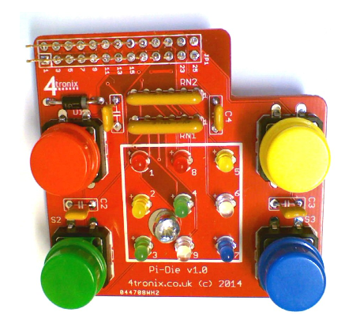

2 The PiDie can be attached directly to your Pi, whilst still making the Pins available.

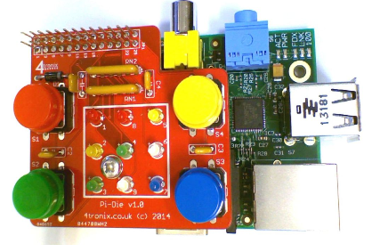

3 PiDie LEDs are on physical pins as follows:

Led1: 7

Led2: 11

Led3: 12

Led4: 13

Led5: 15

Led6: 16

Led7: 18

Led8: 22

Led9: 8

Buttons on physical pins as follows:

Red: 21

Green: 19

Yellow: 24

Blue: 26

4 Some sample Scratch programs have been provided to get you going.

**testLEDs.sb** - Uses the number keys on keyboard to turn same number LED on and off

**testButtons.sb** - Switches on the LED next to each button when the button is pressed

**Simon_SDM.sb -** A complete Simon game: By Sjoerd Dirk Meijer - @fromScratchEd from http://scratch.mit.edu/projects/11939445/

Note: if you are using the latest Jessy release of Scratch, the same programs will need to be updated for the new GPIO functions. Who fancies a challenge!

More information can be found at the following sites:

<http://scratch.mit.edu/projects/11939445/>

<http://4tronix.co.uk>